Project Design Phase-II
Data Flow Diagram & User Stories

Date | 4 July 2026
Team ID
Project Name
Maximum Marks | 4 Marks

Data Flow Diagrams:
A Data Flow Diagram (DFD) is a traditional visual representation of the information flows within a system. A neat and clear DFD can depict the right amount of the system requirement graphically. It shows how data enters and leaves the system, what changes the information, and where data is stored.

Example: (Simplified)
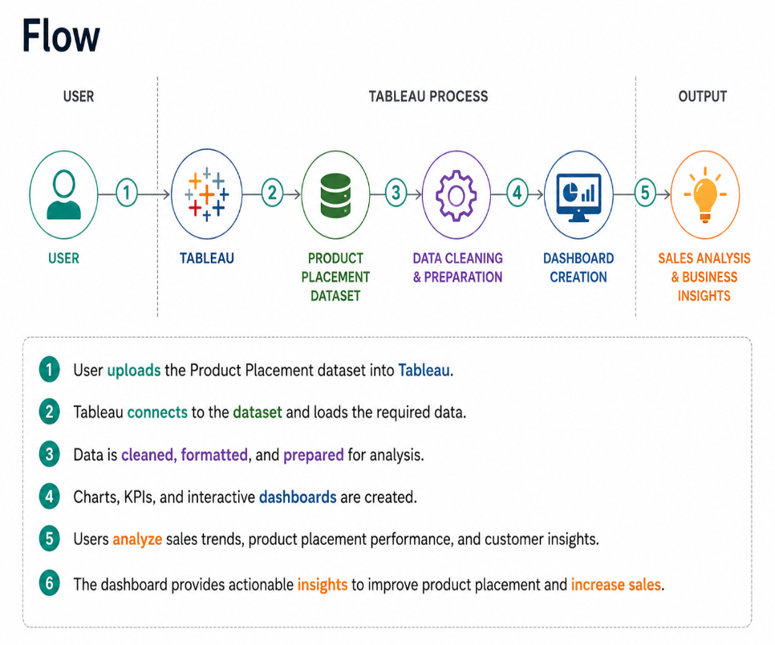

User Stories
Use the below template to list all the user stories for the product.
User Type | Functional Requirement (Epic) | User Story Number | User Story / Task | Acceptance criteria | Priority | Release
Retail manager User Story Number User Story / Task Acceptance Criteria Priority Release | Dataset Upload | USN-1 | As a user, I can upload the product placement dataset into Tableau. | Dataset uploads successfully. | High | Sprint-1
Retail manager | Data preparation | USN-2 | As a user, I can clean and prepare the dataset for analysis. | Cleaned data is ready for visualization | High | Sprint-1
Bussiness Analyst | Dashboard | USN-3 | As a user, I can create interactive dashboards to analyze sales performance. | Dashboard displays charts and KPIs correctly. | high | Sprint-1
Business Analyst | filters | USN-4 | As a user, I can apply filters to analyze specific products, categories, and regions. | Filters update the dashboard correctly. | Medium | Sprint-1
Retail manager | Insights | USN-5 | As a user, I can view product placement insights and sales trends. | Dashboard provides accurate insights. | High | Sprint-2
Customer (Web user) | Reports | USN-6 | As a user, I can download sales reports | Reports download successfully. | Medium | Sprint 2

